**Homework 5**

James Fu

105532210

**Question 1**

a.

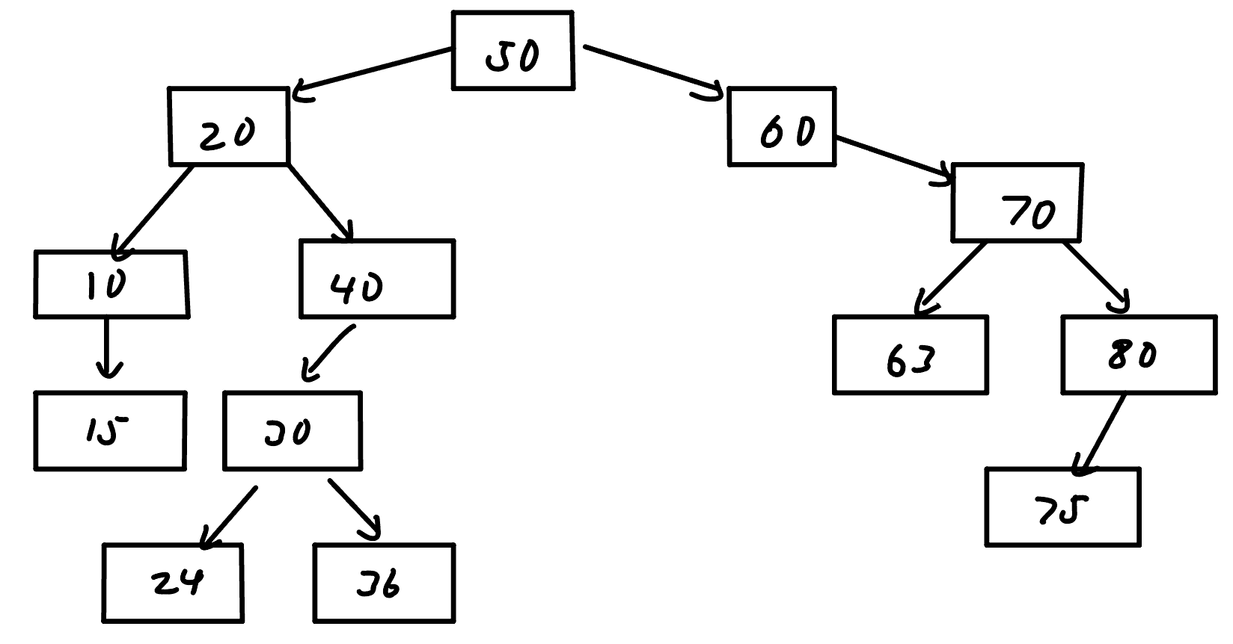

b.

In-order: 10 15 20 24 30 36 40 50 60 63 70 75 80

Pre-order: 50 20 10 15 40 30 24 36 60 70 63 80 75

Post-order: 15 10 24 36 30 40 20 63 75 80 70 60 50

c.

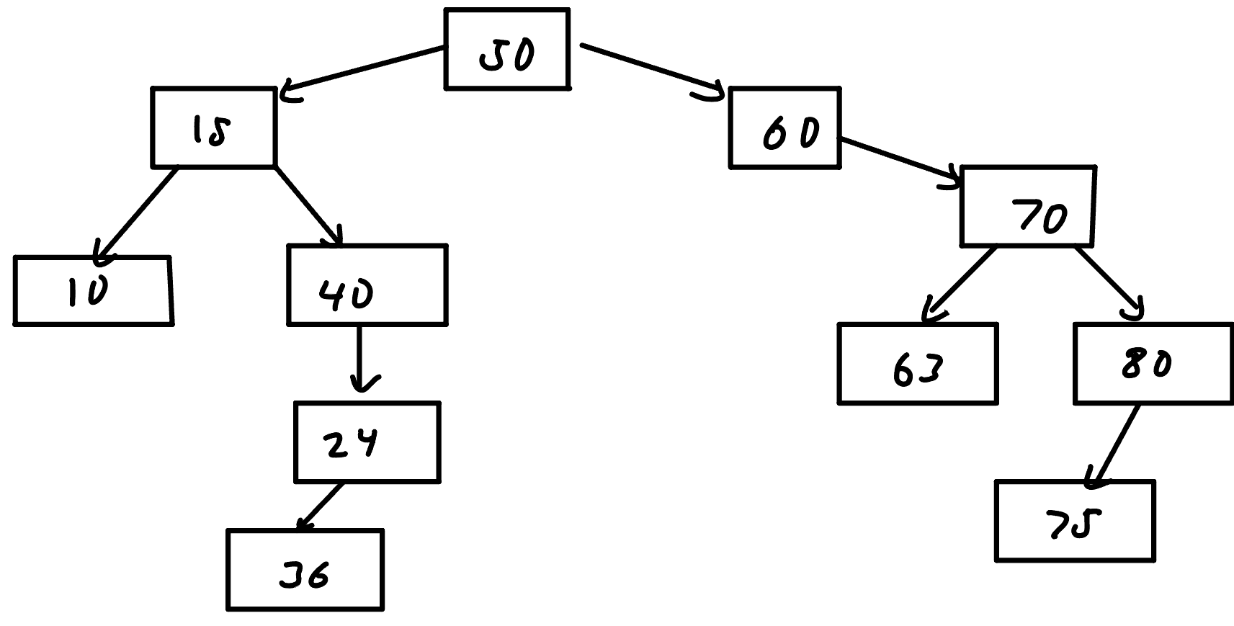

**Question 2**

a.

struct Node {

Node* parent;

Node* left;

Node* right;

int value;

};

b.

void insert(Node* current, int value, Node* par)

Pseudocode:

if current is equal to the null pointer

set current to a new node with num set as the value

set left to null

set right to null

return current

if int value is less than current value

insert the node into the left side (e.g. insert(left of current node, value, current))

if int value is greater than current value

insert the node into the right side (e.g. insert(right of current node, value, current))

// not necessary to return anything bc can pass the return value as a parameter

**Question 3**

a.

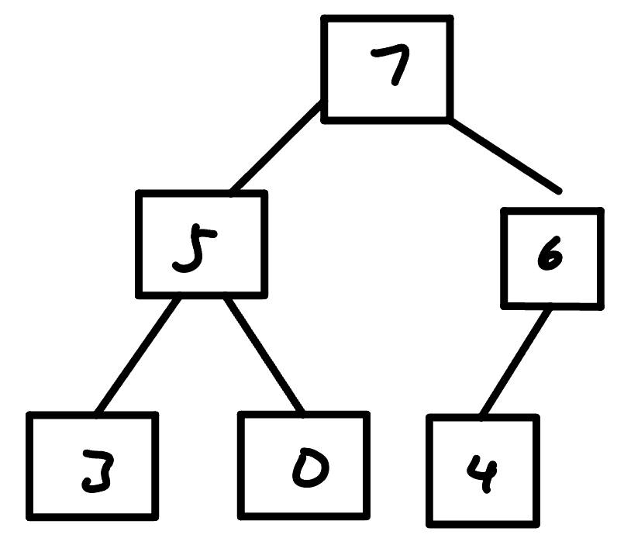

b.

| 7 | 5 | 6 | 3 | 0 | 4 |
| --- | --- | --- | --- | --- | --- |

c.

| 6 | 5 | 4 | 3 | 0 |
| --- | --- | --- | --- | --- |

**Question 4**

a. O(C+S)

b. O(logC + S)

c. O(logC + log S)

d. O(logS)

e. O(1)

f. O(logC + S)

g. O(S logS)

h. O(C logS)